VCE VET
MUSIC (Performance)

- You can study this VCE subject while at your current school and complete this extra study at Bellarine Secondary College.

- Contributes as a VCE unit 3 and 4 sequence, as one of your main four subjects and contributes to your study score.

- Contributes credits to your VCAL studies.

BELLARINE SECONDARY COLLEGE

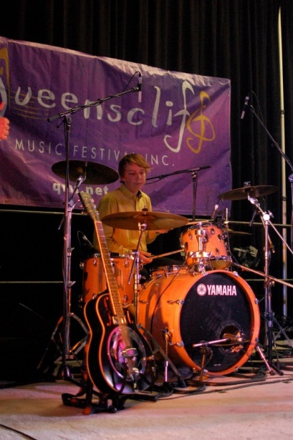
CUA30915

CERTIFICATE III

in MUSIC INDUSTRY

- Students will be supported with bussing transport arrangements to theory and practical classes.

- Enrolments are currently being taken. You must be in at least Year 10, see your VET coordinator at your school for further information.

VET IN SCHOOLS PROGRAM
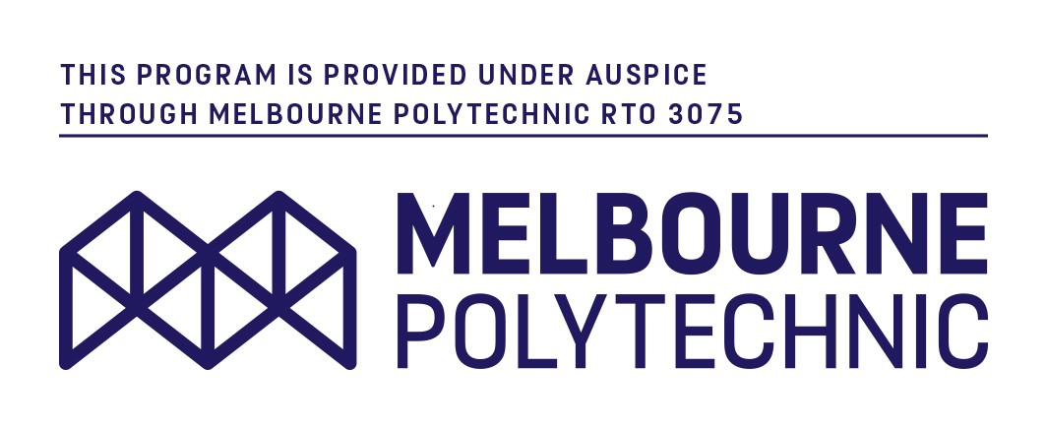
Drysdale Campus: Peninsula Drive DRYSDALE, VIC, 3222

Ocean Grove Campus:
70 Shell Road, OCEAN GROVE, VIC, 3226

COLLEGE PHONE:
03 5251 9000

www.bellarinesc.vic.edu.au

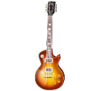
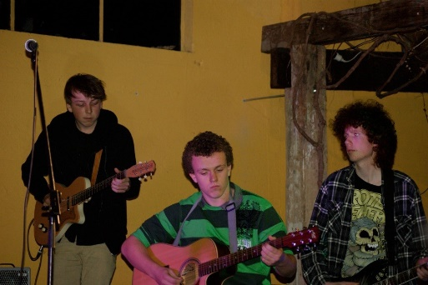
Certificate III in
Music Industry

National Code: | CUA30915
Location: | Bellarine Secondary  College
Study Area: | VET in Schools  Program (VCE)
Study Area: | Music Performance

What does this course involve?
The Certificate III in Music prepares students for work in the music industry in areas such as performance, critical listening, music management and music promotions.

Across the 2 years, students will complete 11 units. 4 are core units, the remaining 7 are made of elective units.

Classes will take place in The Potato Shed next door to Bellarine Secondary College.

Course assessment includes: Oral presentation, written assessment, Practical demonstration, Project work &•Examination and testing
Units of Competency:
Unit 1 & 2 Core and Electives
BSBWHS201 Contribute to health and safety of self and others
CUACMP301 Implement copyright arrangements
CUAIND303 Work effectively in the music industry
CUAMLT302 Apply knowledge of style and genre to music industry practice
CUAMCP301 Compose simple songs or musical pieces
CUAMPF304 Make a music demo
Unit 3 & 4 Core and Electives
CUAMPF301 Develop technical skills in performance
CUAMPF302 Prepare for performances
CUAMPF305 Develop improvisation skills
CUAMPF402 Develop and maintain stagecraft skills
CUAMPF404 Perform music as part of a group
Or
CUAMPF406 Perform music as a soloist.

Accreditation:
- You will receive a nationally recognised certificate.

- You can undertake this course as part of your VCE and receive a study score. You will need to take an external exam and complete your coursework.
What employment opportunities will I have?

With additional training and expertise, potential employment outcomes may include band member, songwriter, Music teacher, arranger, promoter, studio teacher and performer.

What further study options will I have?

You may wish to progress into the Certificate IV in Music, then Diploma of Music and Advanced Diploma of Music.

Recognition

- The Certificate III in Music Industry (Performance) is a VETiS. Secondary school students may receive credit towards satisfactory completion of their VCAL or a score towards their VCE. Assessments for both VCE and VCAL are based on Practical Competence and Theoretical Knowledge.

- The VCE/VCAL component is delivered under the Victorian Curriculum and Assessment Authority (VCAA).

