CUA30915 CERTIFICATE III IN MUSIC INDUSTRY (SOUND PRODUCTION)

GEELONG HIGH SCHOOL

COURSE OVERVIEW:

CUA30915 Certificate III in Music Industry (Sound Production) is offered to students under the auspices of the College of Sound and Music Production (RTO #41549). This qualification is for students who have an interest in music and sound production and are keen to develop skills in a range of areas such as recording, mixing and sound editing.

Sound Production Specialisation provides students with the practical skills and knowledge to record, mix and edit sound sources, and operate sound reinforcement equipment for live music events. The program includes core units such as implementing copyright arrangements, performing basic sound editing and developing music industry knowledge. Elective units provide students with the opportunity to learn the essentials of audio engineering and electronic music production. Students will gain competencies that will enhance their employment opportunities within the music industry, and a recognised qualification that will assist them in making a more informed choice when considering vocational and career pathways.
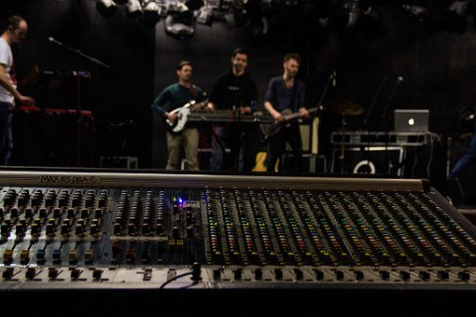

ENROLME
ENROLMENT:

Students are required to submit a short written application including their experience and goals in the field of Music and Sound Production. Students enrolling in the second year of the Certificate III in Music are required to have successfully completed the first year.

CONTACT DETAILS:  Students interested in the Music Industry are invited to contact:  Geelong High School  385 Ryrie St. East Geelong  Tel: 03 5225 4100  Trudy Cameron  VET Coordinator Geelong High School  Trudy.cameron@education.vic.gov.au  The annual fee for this VET Course is $300 first year and $350 second year | CONTRIBUTION TO VCE/VCAL:  VET Music Industry (Sound Production) is a Scored VET course. This means you CAN receive a study score for this subject and it CAN contribute to your ATAR.  • VCE: Students who complete Certificate III in Music Industry will be eligible for up to five Units of credit towards their VCE: up to three at the Unit 1 & 2 level and a Unit 3 & 4 sequence.  • VCAL: This program contributes to the Industry Specific Skills Strand and may also contribute to the Work- Related Skills Strand of VCAL  • ATAR: Students wishing to receive an ATAR contribution for the Unit 3 & 4 sequence must undertake scored assessment for the purposes of gaining a study score. This study score can contribute directly to the primary four or as a fifth or sixth study.

POSSIBLE FUTURE CAREER OPPORTUNTIES:

• Sound Engineer • Producer • Broadcaster • Musician • Performer • Stage Manger
• Digital Audio Technician • Sound & Lighting Technician • Songwriter

PATHWAY OPTIONS:

• CUA40915 Certificate IV in Music Industry
• CUA50815 Diploma of Music Industry
• CUA60515 Advanced Diploma of Music Industry

RTO DETAILS:

College of Sound & Music Production (COSAMP)
RTO #41549
P: (03) 9592 4801 | E: info@cosamp.edu.au
W: cosamp.com.au

